Description : This query evaluates how each acquisition Channel performs by calculating total touchpoint costs, overall revenue, conversion rate, and return on ad spend (ROAS).

Query :

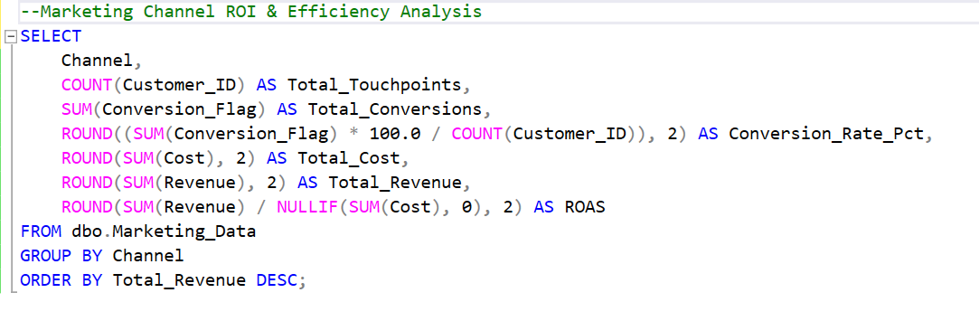

Solution :

